Name: KVNG Vikram

Sc code: sc15b148

**Labsheet 7**

1. Given the following requirements on a filter in continuous time, manually derive the desired ideal frequency response *Hd*(*ejω*) in the discrete frequency domain.

Ans:

Hd(e(jω)) ideally is a rectangular function. Since cutoff frequecy is 1kHz and passband gain For ideal low pass filter having linear phase it should be symmetrical around origin in this Its corresponding impulse response will be hd(n+1)=sinc(ωc*(n-M/2))/4.

1. Let *w*[*n*] be a rectangular window of length *M* + 1. That is

1*,* for *n* ∈ {0*,*1*,...,M*}*, w*[*n*] =

0*,* otherwise.

* 1. Plot the magnitude (in dB) and phase response of the window (i.e., 20*log*10|*W*(*ejω*)| and ∠*W*(*ejω*)) for *M* = 10*,*50 and 100. What do you observe for different values of *M*?
  2. Demonstrate the effect of using rectangular windows with *M* = 10*,*50 and 100 on the *hd*[*n*] obtained in Task 1. That is, for each M, obtain *h*[*n*] = *hd*[*n*]*w*[*n*] and plot the corresponding magnitude and phase plots of the DTFT of *h*[*n*], i.e., *H*(*ejω*). (Magnitude plot should be in dB scale). What do you observe? What are the values of the peak overshoots and undershoots for each value of *M*. Do they change as *M* changes? What do you need to do to ensure that for each value of *M* the phase response is linear?

% w[n] is a rectangular window of length M + 1  
  
M1 = 10;  
M2 = 50;  
M3 = 100;  
df = 0.001;

f = 0 : df : 2*pi ;  
  
n1 = 0:M1;  
w1 = 1+n1*0;  
n2 = 0:M2;  
w2 = 1+n2*0;  
n3 = 0:M3;  
w3 = 1+n3*0;

W1 = zeros(1,numel(f));  
for i = 1:numel(f)  
 for j = 1:numel(n1)  
 W1(i) = W1(i) + w1(j)*exp(-1j*f(i)*n1(j));  
 end  
end  
  
W2 = zeros(1,numel(f));  
for i = 1:numel(f)  
 for j = 1:numel(n2)  
 W2(i) = W2(i) + w2(j)*exp(-1j*f(i)*n2(j));  
 end  
end  
W3 = zeros(1,numel(f));  
for i = 1:numel(f)  
 for j = 1:numel(n3)  
 W3(i) = W3(i) + w3(j)*exp(-1j*f(i)*n3(j));  
 end  
end

figure()  
title('DTFT of w[n]')  
subplot(2,1,1)  
hold()  
title('Normalised Amplitudes in log scale of different window functions')  
plot(f,20*log10(abs(W1)/abs(W1(1))),'b','LineWidth',2)  
plot(f,20*log10(abs(W2)/abs(W2(1))),'r','LineWidth',2)  
plot(f,20*log10(abs(W3)/abs(W3(1))),'g','LineWidth',2)  
legend('M = 10','M = 50','M = 100')  
xlabel('--> Frequency in radiens')  
ylabel('--> 20log|W|')  
  
subplot(2,1,2)  
hold()  
title('Phase plot')  
plot(f,unwrap(angle(W1)*180/pi),'b','LineWidth',2)  
plot(f,unwrap(angle(W2)*180/pi),'r','LineWidth',2)  
plot(f,unwrap(angle(W3)*180/pi),'g','LineWidth',2)  
legend('M = 10','M = 50','M = 100')  
xlabel('--> Frequency in radiens')  
ylabel('--> Phase angle in degrees')

Current plot held  
Current plot held

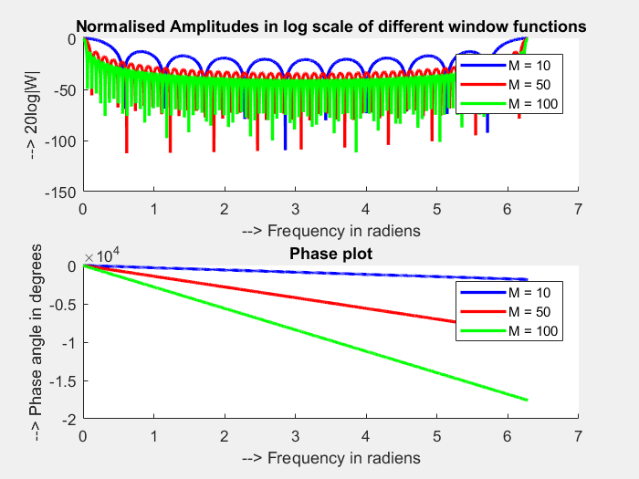

SampleFrequency = 8 ; % kHz  
CutoffFrequency = 1 ; % kHz

sf = SampleFrequency;  
cf = CutoffFrequency;  
  
w_c = pi*cf/sf;  
  
H = 1*double(f<w_c | f>(2*pi - w_c));  
  
h1 = zeros(1,numel(n1));  
for i = 1:numel(n1)  
 for j = 1:numel(f)  
 h1(i) = h1(i) + H(j)*exp(1j*f(j)*n1(i))*df/(2*pi);  
 end  
end  
  
h2 = zeros(1,numel(n2));  
for i = 1:numel(n2)  
 for j = 1:numel(f)  
 h2(i) = h2(i) + H(j)*exp(1j*f(j)*n2(i))*df/(2*pi);  
 end  
end  
  
h3 = zeros(1,numel(n3));  
for i = 1:numel(n3)  
 for j = 1:numel(f)  
 h3(i) = h3(i) + H(j)*exp(1j*f(j)*n3(i))*df/(2*pi);  
 end  
end

figure()  
subplot(3,1,1)  
stem(n1,real(h1))  
title('IDTFT of h[n] with M = 10')  
xlabel('--> n')  
ylabel('--> Amplitude')  
subplot(3,1,2)  
stem(n2,real(h2))  
title('IDTFT of h[n] with M = 50')  
xlabel('--> n')  
ylabel('--> Amplitude')  
subplot(3,1,3)  
stem(n3,real(h3))  
title('IDTFT of h[n] with M = 100')  
xlabel('--> n')  
ylabel('--> Amplitude')

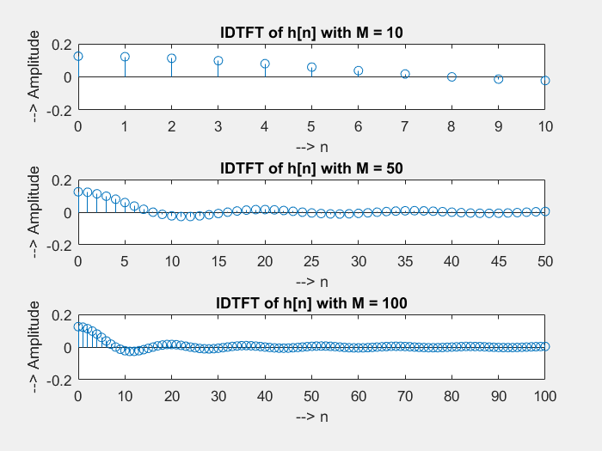

H1 = zeros(1,numel(f));  
for i = 1:numel(f)  
 for j = 1:numel(n1)  
 H1(i) = H1(i) + h1(j)*exp(-1j*f(i)*n1(j));  
 end  
end  
  
H2 = zeros(1,numel(f));  
for i = 1:numel(f)  
 for j = 1:numel(n2)  
 H2(i) = H2(i) + h2(j)*exp(-1j*f(i)*n2(j));  
 end  
end  
  
H3 = zeros(1,numel(f));  
for i = 1:numel(f)  
 for j = 1:numel(n3)  
 H3(i) = H3(i) + h3(j)*exp(-1j*f(i)*n3(j));  
 end  
end

figure()  
subplot(2,1,1)  
hold()  
title('Normalised Amplitudes in log scale for different h[n]')  
plot(f,20*log10(abs(H1)/abs(H1(1))),'b','LineWidth',2)  
plot(f,20*log10(abs(H2)/abs(H2(1))),'r','LineWidth',2)  
plot(f,20*log10(abs(H3)/abs(H3(1))),'g','LineWidth',2)  
xlabel('--> Frequency in radians')  
ylabel('--> 20log|H|')  
legend('M = 10','M = 50','M = 100')  
  
subplot(2,1,2)  
hold()  
title('Phase for different h[n]')  
plot(f,unwrap(angle(H1)*180/pi),'b','LineWidth',2)  
plot(f,unwrap(angle(H2)*180/pi),'r','LineWidth',2)  
plot(f,unwrap(angle(H3)*180/pi),'g','LineWidth',2)  
xlabel('--> Frequency in radians')  
ylabel('--> phase in degrees')  
legend('M = 10','M = 50','M = 100')

Current plot held  
Current plot held

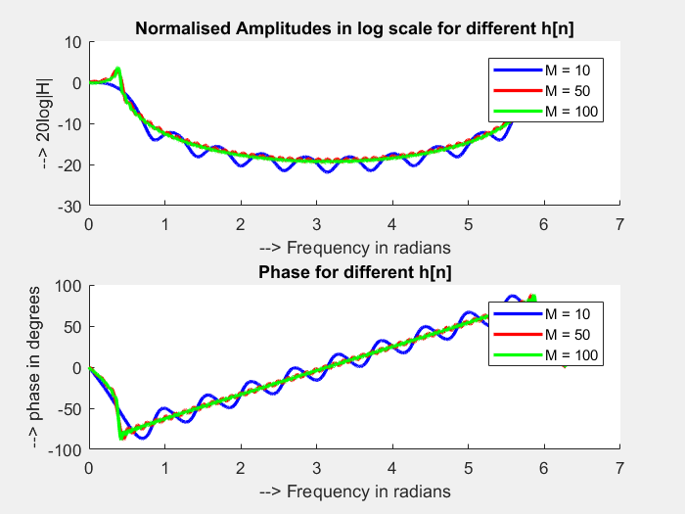

[*Published with MATLAB® R2017a*](http://www.mathworks.com/products/matlab)

1. Study what the following inbuilt Matlab window functions do:
   1. bartlett
   2. hamming (c) hanning
   3. blackman
   4. Kaiser

Ans:

a) bartlett Bartlett window. W = bartlett(N) returns the N-point Bartlett window.

b) Hamming window. hamming(N) returns the N-point symmetric Hamming window in a column vector.

c) Hanning window. hanning(N) returns the N-point symmetric Hanning window in a column vector. Note that the first and last zero-weighted window samples are not included. hanning(N,'symmetric') returns the same result as hanning(N). hanning(N,'periodic') returns the N-point periodic Hanning window, and includes the first zero-weighted window sample.

d) Blackman window.blackman(N) returns the N-point symmetric Blackman window in a column vector. blackman(N,SFLAG) generates the N-point Blackman window usingSFLAG window sampling. SFLAG may be either 'symmetric' or 'periodic'. By default, a symmetric window is returned.

e) kaiser Kaiser window. W =kaiser(N) returns an N-point Kaiser window in the column vector W.W = kaiser(N,BTA) returns the BETA-valued N-point Kaiser window. If omitted, BTA is set to 0.500.

1. In Task 3 above, you would have found that each function can be used to generate windows *w*[*n*] of any needed length. If length *M* + 1 windows are generated, then *w*[*n*] has symmetry around (*M* + 1)*/*2.
2. For each window function above, plot the magnitude (in dB) and phase response of the window (i.e., 20*log*10|*W*(*ejω*)| and ∠*W*(*ejω*)) for *M* = 10*,*50 and 100. Observe and tabulate the maximum sidelobe amplitude and the width of the main lobe for each window and for each *M*.
3. For each *M* and for each window function above, i.e., a *w*[*n*], plot the magnitude (in dB) of the filter that would be obtained when using the FIR response *h*[*n*] = *w*[*n*]*hd*[*n*], where *hd*[*n*] is the desired response derived in Task 1. What is the peak approximation error (in dB) that you obtain for each window and for each *M*? Again make sure that each filter has a linear phase response.

omega=-pi:0.01:pi;  
M=100; %Length of window=M+1  
w=bartlett(M+1);% window name change name here for obtaining different window  
W=0;  
for n=0:M  
W=W+ w(n+1)*exp(-j.*omega*n);  
end;  
subplot(2,1,1);  
plot(omega,20*log10(abs(W)));  
xlabel('Frequency,w');  
ylabel('Magnitude,dB');  
title('Magnitude Response');  
subplot(2,1,2);  
plot(omega,unwrap(angle(W)));  
xlabel('Frequency,w');  
ylabel('Angle,rad');  
title('Phase Response');

M=input('Enter the value of M ');  
f=-pi:0.01:pi;  
wc=pi/4;  
w=bartlett(M+1); %window function for other windows change the name  
H=0;  
for n=0:M  
hd(n+1)=sinc(wc*(n-M/2))/4;  
h(n+1)=w(n+1)*hd(n+1);  
end  
for k=0:numel(f)-1  
H(k+1)=0;  
for n=0:M;  
H(k+1)=H(k+1)+h(n+1).*exp(-1j.*n.*f(k+1));  
end  
end  
figure  
subplot(2,1,1)  
plot(f,20*log10(abs(H)));  
subplot(2,1,2)  
plot(f,angle(H))

For M= 10

Bartlett

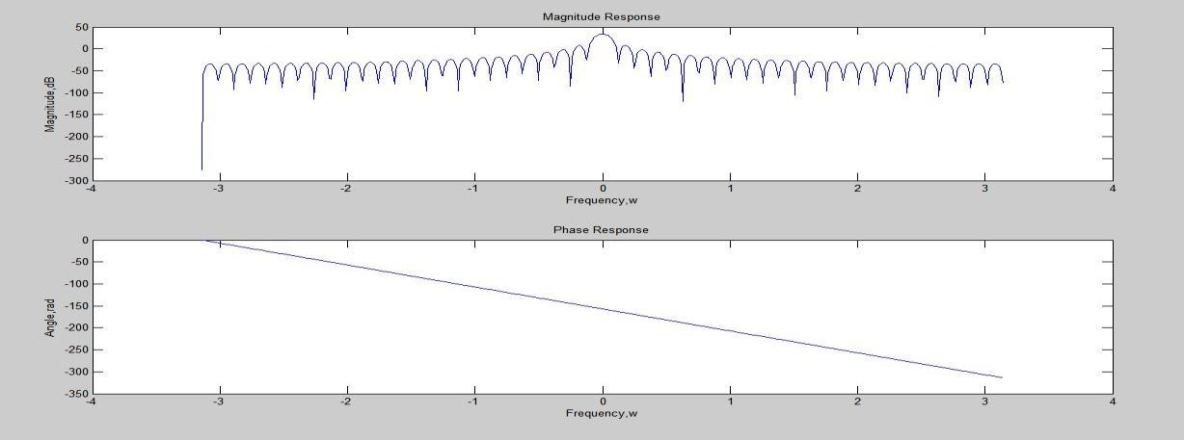

Magnitude using FIR Response

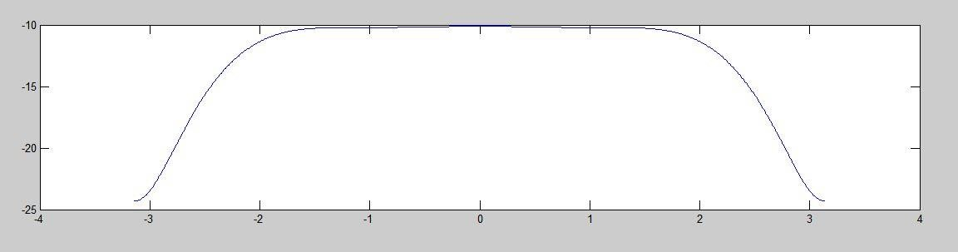

Hamming

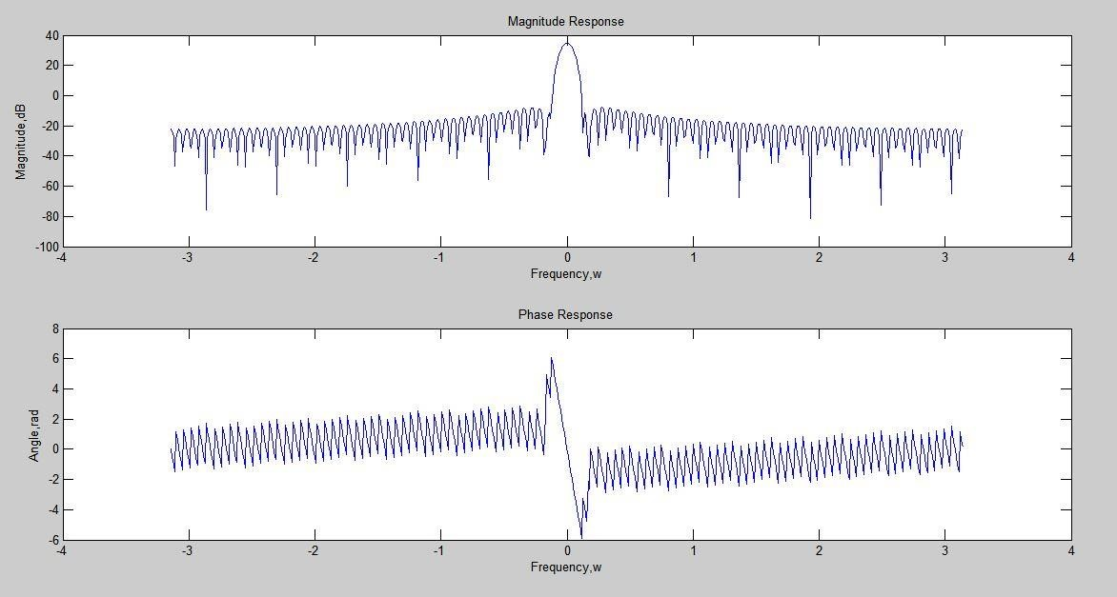

Magnitude using FIR Response

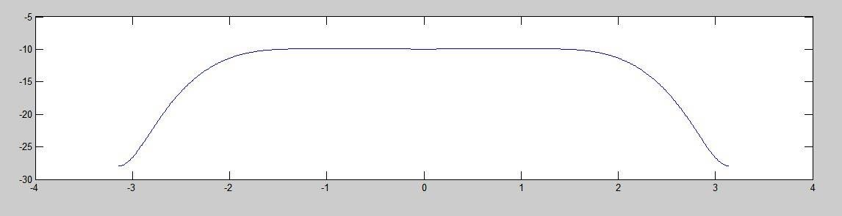

Hanning

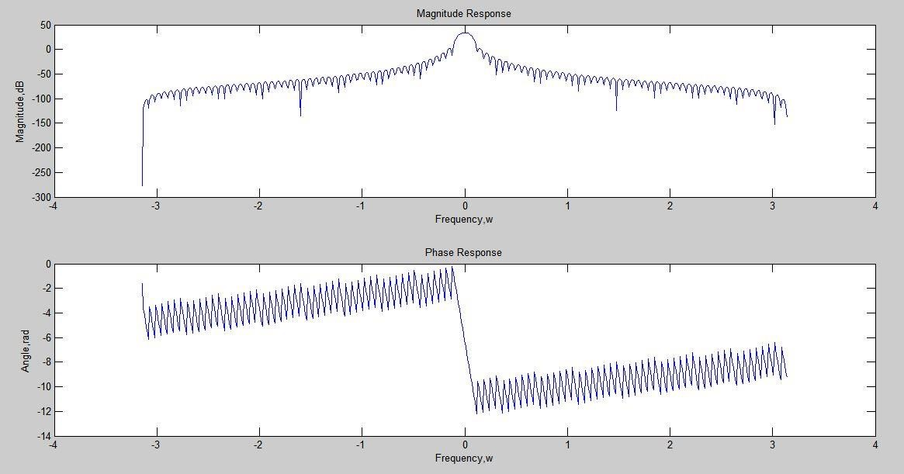

Magnitude using FIR response

Blackman

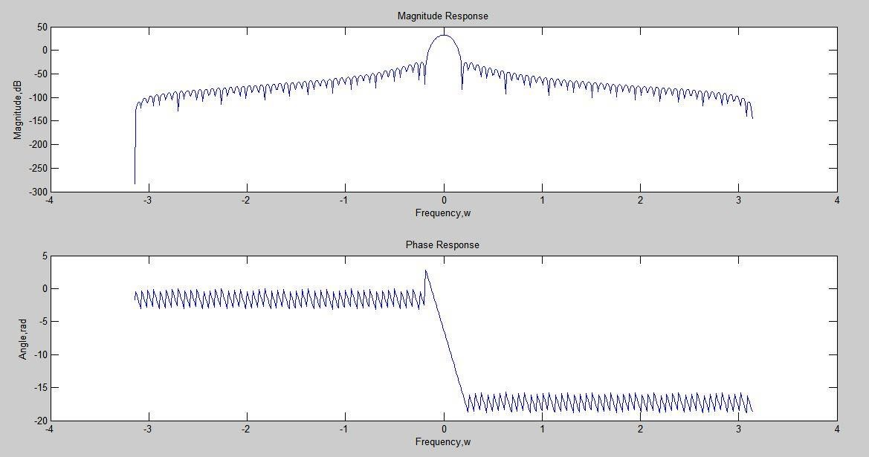

Magnitude using FIR Response

